Ms. Wun’s Computer Parts Store



Keyboard

$61.99

Mouse

$24.99

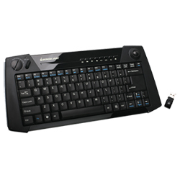

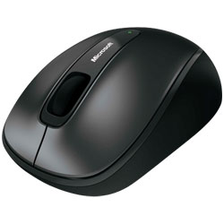



Monitor

$164.99

320 Gb HD

$54.99

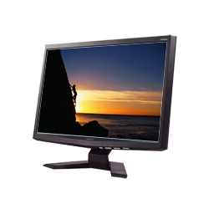

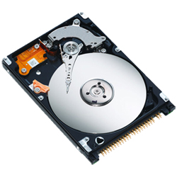



Laser Printer

$249.99

32 Gb USB Key

$99.97

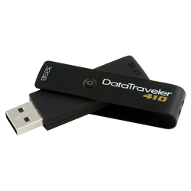
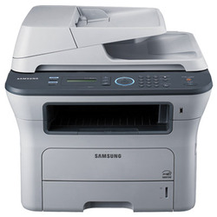


i5-580 Processor

$266.00

Microphone

$45.99

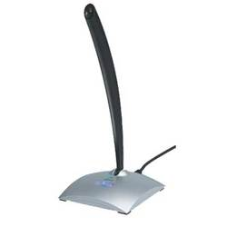
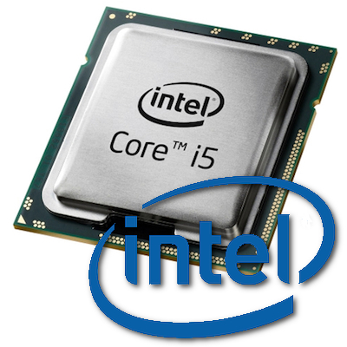



MSI Video Card

$159.97

ASUS Motherboard

$78.97

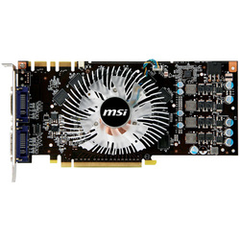

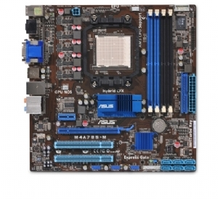



End of Transaction
Refund

